**Day 17 Task: Docker Project for DevOps Engineers.**

task:

* Create a Docker file for a simple web application (e.g. a Node.js or Python app)

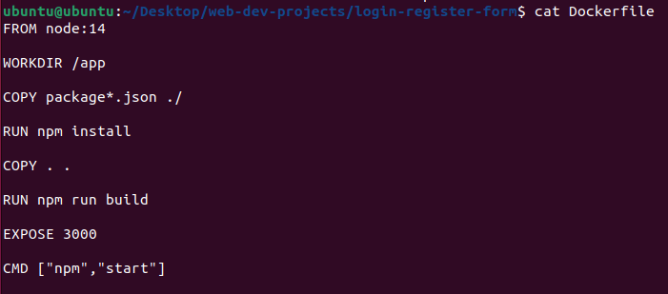

* Build the image using the Dockerfile and run the container  
    
  **Building an Docker image below**

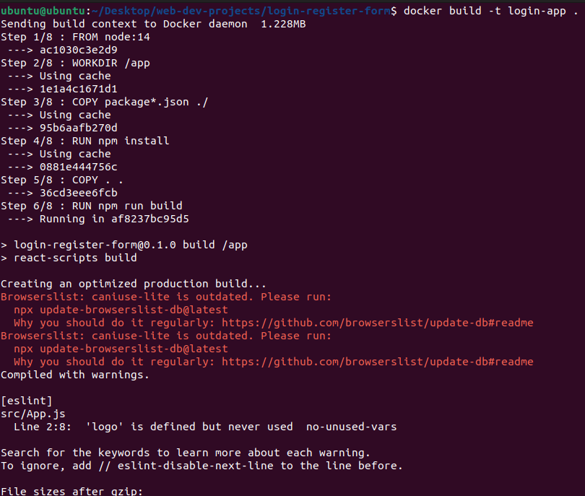



**Running / executing the docker image   
  
**

* Verify that the application is working as expected by accessing it in a web browser

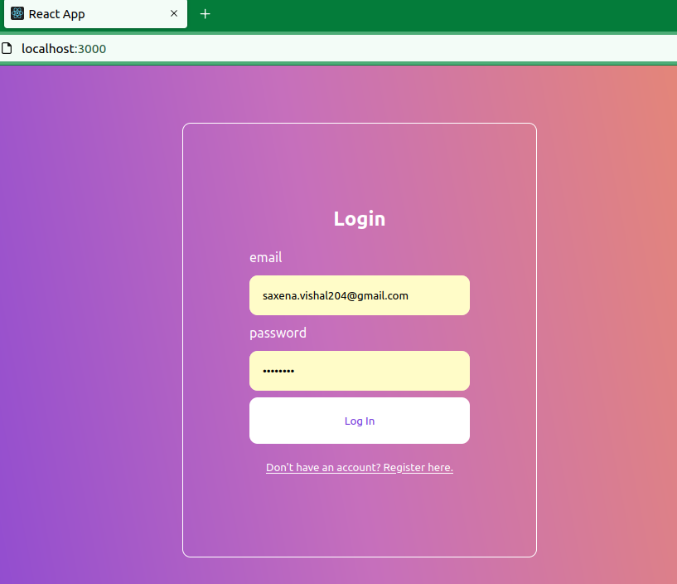

* Push the image to a public or private repository (e.g. Docker Hub )

